A Comprehensive Review Of Cryptographic Techniques In Federated Learning For Secure Data
Abstract:
Federated Learning (FL) has gained significant attention as a distributed machine learning paradigm that enables collaborative model training while keeping sensitive data localized at client devices. Although FL reduces the risks associated with centralized data collection, it does not inherently ensure complete data privacy or security, as shared model updates can still leak sensitive information and are vulnerable to adversarial attacks. To mitigate these risks, a variety of cryptographic techniques have been integrated into federated learning frameworks, including secure aggregation, homomorphic encryption, secure multiparty computation, differential privacy, and blockchain-based security mechanisms. This comprehensive review systematically examines and categorizes existing cryptographic approaches used to enhance data confidentiality, integrity, and robustness in federated learning systems. The paper analyzes the strengths, limitations, and performance trade-offs of these techniques in terms of computational complexity, communication overhead, scalability, and model accuracy. Additionally, current challenges, open research issues, and future directions are discussed, emphasizing the need for lightweight, adaptive, and scalable cryptographic solutions. This review aims to provide researchers and practitioners with a structured understanding of secure federated learning and to guide the design of privacy-preserving and trustworthy distributed learning systems.

Existing System:
The rapid adoption of Federated Learning (FL) has emerged as a promising paradigm for collaborative model training without centralizing sensitive data, making it particularly suitable for privacy-critical domains such as healthcare, finance, and smart IoT systems. However, despite its decentralized nature, federated learning remains vulnerable to a wide range of security and privacy threats, including inference attacks, model poisoning, gradient leakage, and adversarial manipulation during communication and aggregation phases. The exchange of model updates rather than raw data does not inherently guarantee data confidentiality, as attackers can exploit shared gradients or parameters to reconstruct sensitive information. This exposes a critical gap between the perceived and actual security guarantees of federated learning systems. These challenges, numerous cryptographic techniques—such as secure multiparty computation, homomorphic encryption, differential privacy, and secure aggregation protocols—have been proposed to enhance data protection in federated learning environments. However, these solutions often introduce significant trade-offs in terms of computational overhead, communication cost, scalability, and model accuracy. Moreover, the lack of standardized frameworks and comparative evaluations makes it difficult for practitioners to select appropriate cryptographic mechanisms tailored to specific application requirements. As federated learning continues to evolve and scale across heterogeneous and resource-constrained environments, there is a pressing need for a comprehensive review that systematically analyzes existing cryptographic techniques, identifies their limitations, and highlights open research challenges in achieving robust, efficient, and scalable security for federated learning systems.

Proposed System:
A structured and comprehensive review framework to analyze cryptographic techniques employed in federated learning for secure data sharing and model training. The proposed approach systematically classifies existing methods into key categories, including secure aggregation protocols, homomorphic encryption, secure multiparty computation, differential privacy, and hybrid cryptographic models. Each category is examined based on clearly defined evaluation criteria such as privacy guarantees, resistance to known attacks, computational and communication overhead, scalability, and impact on learning performance. By adopting a comparative and taxonomy-driven analysis, the proposed review framework enables a unified understanding of how different cryptographic mechanisms address specific security challenges in federated learning environments. Furthermore, the proposed study integrates a threat-model-based perspective to map cryptographic techniques to corresponding attack vectors, including inference attacks, poisoning attacks, and Byzantine failures. The review also highlights practical deployment considerations across heterogeneous and resource-constrained environments, such as edge and IoT systems. Through this systematic analysis, the paper aims to identify existing research gaps and propose future research directions focused on lightweight, adaptive, and interoperable cryptographic solutions. The proposed framework serves as a reference guideline for researchers and practitioners seeking to design robust, secure, and efficient federated learning systems.

Disadvantage:
Despite their effectiveness in enhancing privacy and security, cryptographic techniques in federated learning introduce several notable disadvantages that limit their practical adoption. Many cryptographic methods, such as homomorphic encryption and secure multiparty computation, incur high computational and communication overhead, making them unsuitable for resource-constrained environments like mobile devices and IoT nodes. Secure aggregation protocols often require multiple rounds of communication and synchronization, increasing latency and reducing system scalability in large-scale federated networks. Additionally, the integration of differential privacy can degrade model accuracy due to the injection of noise, particularly when strict privacy budgets are enforced. Moreover, the complexity of implementing and managing cryptographic mechanisms in federated learning systems poses significant challenges. Key management, protocol orchestration, and fault tolerance become increasingly difficult in dynamic and heterogeneous environments where clients may frequently join or leave the network. Many existing approaches assume honest or semi-honest participants, limiting their effectiveness against fully malicious adversaries. Furthermore, the lack of standardized benchmarks and unified evaluation frameworks makes it difficult to objectively compare cryptographic techniques across different datasets and application domains. These limitations highlight the need for more efficient, adaptive, and standardized cryptographic solutions to achieve practical and scalable secure federated learning.

Advantage:
The integration of cryptographic techniques into federated learning offers significant advantages in ensuring secure and privacy-preserving collaborative model training. By leveraging mechanisms such as secure aggregation, homomorphic encryption, secure multiparty computation, and differential privacy, federated learning systems can effectively protect sensitive data from leakage during model updates and communication. These techniques enable strong guarantees of data confidentiality, integrity, and access control, even in untrusted or semi-trusted environments. As a result, organizations can collaboratively train high-quality models while complying with data protection regulations and preserving user privacy. In addition to enhanced security, cryptographic techniques improve trust, robustness, and adoption of federated learning across critical application domains. Secure protocols reduce the risk of inference attacks, model poisoning, and unauthorized data reconstruction, thereby strengthening system reliability. Cryptographic integration also supports decentralized data ownership and minimizes dependence on centralized data storage, reducing single points of failure. Furthermore, hybrid cryptographic approaches allow flexible trade-offs between privacy, performance, and scalability, making federated learning suitable for diverse real-world scenarios such as healthcare, finance, and edge computing. Overall, cryptographic techniques play a crucial role in enabling secure, compliant, and scalable federated learning systems.

Software Requirement:
SYSTEM REQUIREMENTS
MINIMUM HARDWARE REQUIREMENTS:

- System : Pentium IV 2.4 GHz.
- Hard Disk : 40 GB.
- Monitor : 15 inch VGA Color.
- Mouse : Logitech Mouse.
- Ram : 512 MB
- Keyboard : Standard Keyboard

MINIMUM SOFTWARE REQUIREMENTS:
- Operating System : Windows XP.
- Platform : PYTHON TECHNOLOGY
- Tool : Python 3.6
- Front End : Python anaconda script
- Back End : Spyder

Module Description:
1. Federated Learning Architecture Analysis
This module focuses on examining the fundamental architecture of federated learning systems, including client–server interactions, decentralized data distribution, and model update workflows. It highlights how data remains at local nodes while only model parameters are exchanged. The module also identifies inherent security vulnerabilities present at different stages of the federated learning lifecycle.
2. Threat and Attack Model Identification
This module analyzes common security and privacy threats in federated learning environments. It covers attacks such as gradient inversion, inference attacks, poisoning attacks, Byzantine behavior, and communication tampering. Understanding these threats provides the foundation for evaluating the effectiveness of cryptographic defenses.
3. Cryptographic Techniques Classification
This module categorizes cryptographic approaches used in federated learning into distinct groups, including secure aggregation protocols, homomorphic encryption, secure multiparty computation, differential privacy mechanisms, and hybrid cryptographic models. Each category is defined and its role in protecting data confidentiality and integrity is discussed.
4. Security and Privacy Evaluation Metrics
This module defines the criteria used to assess cryptographic techniques, such as privacy guarantees, resistance to attack models, communication overhead, computational complexity, scalability, and impact on model accuracy. These metrics ensure consistent and objective comparison across different studies.
5. Comparative Analysis of Existing Approaches
This module performs a systematic comparison of existing cryptographic methods based on the defined evaluation metrics. It highlights the strengths, limitations, and practical trade-offs of each technique when deployed in real-world federated learning scenarios.
6. Application-Specific Use Case Analysis
This module examines how cryptographic techniques are applied in different domains such as healthcare, finance, smart grids, and Internet of Things (IoT) systems. It evaluates domain-specific requirements and challenges related to privacy, latency, and resource constraints.

Algorithm:
The algorithmic framework for secure federated learning using cryptographic techniques follows an iterative and privacy-preserving training process. Initially, a global model is initialized by a central coordinator and distributed to participating client devices. Each client performs local model training using its private dataset without sharing raw data. Before transmission, the locally computed model updates are protected using cryptographic mechanisms such as secure aggregation, homomorphic encryption, or secure multiparty computation, depending on the security requirements. These encrypted or masked updates are then sent to the central server, ensuring confidentiality during communication. Upon receiving the protected updates, the server aggregates them without accessing individual client information, leveraging cryptographic protocols that preserve privacy. The aggregated result is decrypted or securely combined to update the global model, which is then redistributed to clients for the next training round. This process continues iteratively until the model converges. Throughout the training lifecycle, additional security measures such as differential privacy noise injection and participant authentication may be applied to enhance robustness against inference and poisoning attacks. This algorithmic approach enables collaborative learning while maintaining strong data security and privacy guarantees.

Introduction:
Federated Learning (FL) has emerged as a transformative paradigm in distributed machine learning, enabling multiple participants to collaboratively train models without directly sharing raw data. By keeping sensitive data localized at edge devices or organizational boundaries, FL addresses critical privacy concerns associated with centralized data collection. This decentralized approach is particularly valuable in data-sensitive domains such as healthcare, finance, smart grids, and Internet of Things (IoT) ecosystems, where regulatory compliance and user privacy are paramount.
Despite its privacy-aware design, federated learning does not inherently guarantee complete data security. The exchange of model parameters and gradients between clients and servers can unintentionally leak sensitive information through inference attacks or malicious analysis. Adversaries may exploit these vulnerabilities to reconstruct private data, manipulate model updates, or disrupt the learning process. As federated learning deployments grow in scale and complexity, ensuring robust security across communication, aggregation, and training phases becomes a critical challenge.
To mitigate these risks, cryptographic techniques have been increasingly integrated into federated learning frameworks. Approaches such as secure aggregation, homomorphic encryption, secure multiparty computation, differential privacy, and hybrid cryptographic schemes aim to enhance confidentiality, integrity, and trust in collaborative learning systems. These techniques provide mathematical guarantees that protect sensitive information even in untrusted or semi-trusted environments. However, each cryptographic method introduces trade-offs related to computational cost, communication overhead, scalability, and model performance.
The diversity of cryptographic solutions has led to a fragmented research landscape, where methods are often evaluated under different assumptions, threat models, and experimental settings. This lack of standardization makes it difficult to objectively compare techniques and identify the most suitable approaches for specific applications. Moreover, many existing studies focus on isolated security aspects without providing a holistic view of how cryptographic mechanisms interact within federated learning systems.
In this context, this paper presents a comprehensive review of cryptographic techniques applied to federated learning for secure data sharing and model training. The review systematically categorizes existing approaches, analyzes their strengths and limitations, and evaluates them based on security guarantees and performance metrics. By identifying research gaps and open challenges, this work aims to guide researchers and practitioners toward the development of efficient, scalable, and secure federated learning solutions.

Literature survey:
1. Yasmin Makki Mohialden et al. — Secure Federated Learning with a Homomorphic Encryption Model
Abstract: This study proposes a secure federated learning model that integrates homomorphic encryption into the FL training process. The approach begins with initializing a global model and generating an encryption key pair, with the public key shared among all FL participants. Clients encrypt their local data using homomorphic encryption before computing updates, allowing the aggregator to combine encrypted model updates without accessing the raw data. Following aggregation, the global model is decrypted and updated securely. This method significantly strengthens privacy protection by ensuring that sensitive data remains encrypted throughout training, making it suitable for domains where privacy is critical.

2. Weizhao Jin et al. — FedML-HE: An Efficient Homomorphic-Encryption-Based Privacy-Preserving Federated Learning System
Abstract: FedML-HE presents an efficient federated learning framework that applies homomorphic encryption (HE) selectively to model parameters to balance privacy and performance. By encrypting only sensitive parameters, the system drastically reduces both computational and communication overhead, making HE-based secure aggregation more practical for large-scale models such as ResNet-50 and BERT. The optimized architecture significantly lowers resource demands while preserving strong privacy guarantees, demonstrating that scalable, secure model training with HE is feasible in real-world scenarios.

3. Zizhen Liu et al. — DHSA: Efficient Doubly Homomorphic Secure Aggregation for Cross-silo Federated Learning
Abstract: This work introduces DHSA, a secure aggregation protocol tailored for cross-silo federated learning using multi-key homomorphic encryption (MKHE) combined with seed homomorphic pseudorandom generation. The scheme resists collusion by up to (N-2) participants without requiring a trusted third party and enhances both security and efficiency. By using homomorphic properties to streamline computation and reduce communication cost, the protocol achieves high performance suitable for privacy-sensitive institutional collaborations such as healthcare or finance.

4. Xue Yang et al. — An Efficient and Multi-private Key Secure Aggregation for Federated Learning
Abstract: This paper proposes a novel secure aggregation scheme that overcomes common limitations of traditional homomorphic encryption or threshold secret sharing approaches. The multi-private key secure aggregation method uses customized ElGamal encryption to support homomorphic addition without relying on a trusted third party, while efficiently compressing high-dimensional model parameters for reduced encryption and communication cost. The protocol achieves semantic security for local gradients and strong robustness against client collusion or dropouts, with negligible impact on model accuracy compared to non-private FL.

5. Shashi Raj K et al. — Federated Learning and Cryptography: A Secure Framework for IoT Data Privacy
Abstract: This research develops a secure IoT framework that combines Federated Learning with cryptographic mechanisms such as additive homomorphic encryption and secure multi-party computation. The design enables confidential aggregation of model updates across resource-constrained IoT devices, maintaining data privacy while reducing communication and computational overhead. The approach is particularly suitable for heterogeneous IoT environments like smart cities and healthcare systems, where data privacy is a priority and device resources are limited.

SRS:
Software Description:
Anaconda is an open-source distribution of the Python and R programming languages for data science that aims to simplify package management and deployment. Package versions in Anaconda are managed by the package management system, conda, which analyzes the current environment before executing an installation to avoid disrupting other frameworks and packages.
The Anaconda distribution comes with over 250 packages automatically installed. Over 7500 additional open-source packages can be installed from PyPI as well as the conda package and virtual environment manager. It also includes a GUI (graphical user interface), Anaconda Navigator, as a graphical alternative to the command line interface. Anaconda Navigator is included in the Anaconda distribution, and allows users to launch applications and manage conda packages, environments and channels without using command-line commands. Navigator can search for packages, install them in an environment, run the packages and update them.

The big difference between conda and the pip package manager is in how package dependencies are managed, which is a significant challenge for Python data science. When pip installs a package, it automatically installs any dependent Python packages without checking if these conflict with previously installed packages. It will install a package and any of its dependencies regardless of the state of the existing installation. Because of this, a user with a working installation of, for example Tensor Flow, can find that it stops working after using pip to install a different package that requires a different version of the dependent NumPy library than the one used by Tensor Flow. In some cases, the package may appear to work but produce different results in execution. In contrast, conda analyzes the current environment including everything currently installed, and together with any version limitations specified (e.g., the user may wish to have Tensor Flow version 2.0 or higher), works out how to install a compatible set of dependencies, and shows a warning if this cannot be done.
Open source packages can be individually installed from the Anaconda repository, Anaconda Cloud (anaconda.org), or the user’s own private repository or mirror, using the conda install command. Anaconda Inc. compiles and builds the packages available in the Anaconda repository itself, and provides binaries for Windows 32/64-bit, Linux 64-bit and MacOS 64-bit. Anything available on PyPI may be installed into a conda environment using pip, and conda will keep track of what it has installed itself and what pip has installed.
Differences between Anaconda and Data Science Platforms
While Anaconda supports some functionality you find in a data science platform, like Domino, it provides a subset of that functionality. Domino and other platforms not only support package management, but they also support capabilities like collaboration, reproducibility, scalable compute, and model monitoring. Conda can be used within the Domino environment.

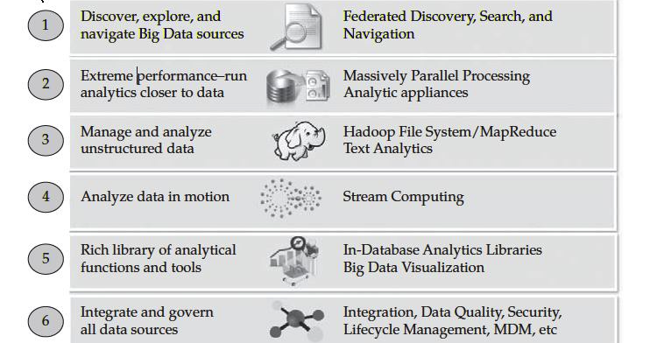

Anaconda is an amazing collection of scientific Python packages, tools, resources, and IDEs. This package includes many important tools that a Data Scientist can use to harness the incredible force of Python. Anaconda individual edition is free and open source. This makes working with Anaconda accessible and easy. Just go to the website and download the distribution.
With over 20 million users, covering 235 regions, and with over 2.4 billion package downloads; Anaconda has grown an exceptionally large community. Anaconda makes it easy to connect to several different scientific, Machine Learning, and Data Science packages.

The key features:
Neural Networks
Machine Learning
Predictive Analytics
Data Visualization
Bias Mitigation
If you are interested in Data Science, then you should know about this Python Distribution. Anaconda is great for deep models and neural networks. You can build models, deploy them, and integrate with leading technologies in the subject. Anaconda is optimized to run efficiently for machine learning tasks and will save you time when developing great algorithms. Over 250 packages are included in the distribution. You can install other third-party packages through the Anaconda terminal with conda install. With over 7500 data science and machine learning packages available in their cloud-based repository, almost any package you need will be easily accessible. Anaconda offers individual, team, and enterprise editions. Included also is support for the R programming language.
The Anaconda distribution comes with packages that can be used on Windows, Linux, and MacOS. The individual edition includes popular package names like numpy, pandas, scipy, sklearn, tensorflow, pytorch, matplotlib, and more. The Anaconda Prompt and PowerShell makes working within the file system easy and manageable. Also, the GUI interface on Anaconda Navigator makes working with the everything exceptionally smooth. Anaconda is an excellent choice if you are looking for a thriving community of Data Scientists and ever-growing support in the industry. Conducting Data Science projects is an increasingly simpler task with the help of great tools like this.
Open Source software that allows Data Scientist to conduct workflows and effectively realize scientific and computational solutions. With an emphasis on presentation and readability, Jupyter Notebooks are a smart choice for collaborative projects as well and insightful publications. Jupyter Notebooks are open source and developed on GitHub publicly by the Jupyter community.
A top-notch Python IDE that is packed full of features and pre-installed packages. With comfortable environment management and an easy to setup workstation, PyCharm is in a league of its own, when it comes to Python. With community, professional, and enterprise editions, there is a version for everyone.
Spyder:
A highly advanced Data Science Python platform. Created with Python for Python, this IDE boasts some immensely robust toolsets. With an editor, IPython Console, Variable Explorer, Advanced Plot Functionality, a built-in debugger, and object doc helper tools, the Spyder IDE is a promising choice for a large amount of Data Science tasks.
Link your datasets and data to a single graph or figure with Glueviz. This Python library allows you to view data visualizations by combining datasets an using the logical links within them.
If Data Mining is your goal, then Orange 3 has you covered. Orange 3 is a toolset built for Data Mining. They offer great GUI, extendable functionality with add-ons, data management, and interactive data visualizations. Also, loved by the teaching and student communities for its immersive visualizations, figures, and graphs.
If you are new to Data Science and want to get the complete experience with Python or if you are an experienced seasoned Data Scientist that is looking for more functionality and efficiency, I really recommend you look at this amazing distribution. It makes package management and deployment quick and easy. Packed with tools, IDEs, packages & libraries Anaconda is a truly authentic decision for Data Science. Because popularity for Anaconda seems to be expanding in many industries and areas that are new to having the availability to such advanced capabilities, it has never been a better time to start with this ever growing package of tools and resources. I hope this article helped detail the Anaconda distribution to anyone who wanted to know more about what it brings to the table and includes. Thank you for reading and happy coding!

Functional requirement:
A functional requirement is a specific, documented feature that a software system must perform. These requirements define the behavior or functionality of the system in terms of inputs, outputs, and processing. Here's an example paragraph outlining functional requirements for a project management software:

"The project management software shall allow users to create new projects, specifying a project name, description, start date, and end date. Users should be able to add tasks to each project, including task name, description, start date, due date, and assigned team member(s). The software must support task dependencies, allowing users to specify relationships between tasks such as 'finish-to-start', 'start-to-start', 'finish-to-finish', or 'start-to-finish'. Additionally, users must be able to assign priorities to tasks and set reminders for upcoming deadlines. The software should provide a dashboard for users to view project timelines, task progress, and resource allocation. Finally, the system must generate reports on project status, including completed tasks, overdue tasks, and resource utilization."
Non-functional requirement
In systems engineering and requirements engineering, a non-functional requirement is a requirement that specifies criteria that can be used to judge the operation of a system, rather than specific behaviors. They are contrasted with functional requirements that define specific behavior or functions. Non-functional requirements add tremendous value to business analysis. It is commonly misunderstood by a lot of people. It is important for business stakeholders, and Clients to clearly explain the requirements and their expectations in measurable terms. If the non-functional requirements are not measurable then they should be revised or rewritten to gain better clarity. For example, User stories help in mitigating the gap between developers and the user community in Agile Methodology.
Usability:
Prioritize the important functions of the system based on usage patterns.
Frequently used functions should be tested for usability, as should complex and critical functions. Be sure to create a requirement for this.
Reliability:
Reliability defines the trust in the system that is developed after using it for a period of time. It defines the likeability of the software to work without failure for a given time period.
The number of bugs in the code, hardware failures, and problems can reduce the reliability of the software.
Your goal should be a long MTBF (mean time between failures). It is defined as the average period of time the system runs before failing.
Create a requirement that data created in the system will be retained for a number of years without the data being changed by the system.
It’s a good idea to also include requirements that make it easier to monitor system performance.
Performance:
What should system response times be, as measured from any point, under what circumstances?
Are there specific peak times when the load on the system will be unusually high?
Think of stress periods, for example, at the end of the month or in conjunction with payroll disbursement.
Supportability:
The system needs to be cost-effective to maintain.
Maintainability requirements may cover diverse levels of documentation, such as system documentation, as well as test documentation, e.g. which test cases and test plans will accompany the system.

SYSTEM STUDY
2.1 FEASIBILITY STUDY
The feasibility of the project is analyzed in this phase and business proposal is put forth with a very general plan for the project and some cost estimates. During system analysis the feasibility study of the proposed system is to be carried out. This is to ensure that the proposed system is not a burden to the company. For feasibility analysis, some understanding of the major requirements for the system is essential.

Three key considerations involved in the feasibility analysis are
- ECONOMICAL FEASIBILITY
- TECHNICAL FEASIBILITY
- SOCIAL FEASIBILITY
ECONOMICAL FEASIBILITY
This study is carried out to check the economic impact that the system will have on the organization. The amount of fund that the company can pour into the research and development of the system is limited. The expenditures must be justified. Thus the developed system as well within the budget and this was achieved because most of the technologies used are freely available. Only the customized products had to be purchased.

TECHNICAL FEASIBILITY
This study is carried out to check the technical feasibility, that is, the technical requirements of the system. Any system developed must not have a high demand on the available technical resources. This will lead to high demands on the available technical resources. This will lead to high demands being placed on the client. The developed system must have a modest requirement, as only minimal or null changes are required for implementing this system.
SOCIAL FEASIBILITY
The aspect of study is to check the level of acceptance of the system by the user. This includes the process of training the user to use the system efficiently. The user must not feel threatened by the system, instead must accept it as a necessity. The level of acceptance by the users solely depends on the methods that are employed to educate the user about the system and to make him familiar with it. His level of confidence must be raised so that he is also able to make some constructive criticism, which is welcomed, as he is the final user of the system.

SYSTEM TESTING

The purpose of testing is to discover errors. Testing is the process of trying to discover every conceivable fault or weakness in a work product. It provides a way to check the functionality of components, sub-assemblies, assemblies and/or a finished product It is the process of exercising software with the intent of ensuring that the
Software system meets its requirements and user expectations and does not fail in an unacceptable manner. There are various types of test. Each test type addresses a specific testing requirement.

TYPES OF TESTS

Unit testing
Unit testing involves the design of test cases that validate that the internal program logic is functioning properly, and that program inputs produce valid outputs. All decision branches and internal code flow should be validated. It is the testing of individual software units of the application .it is done after the completion of an individual unit before integration. This is a structural testing, that relies on knowledge of its construction and is invasive. Unit tests perform basic tests at component level and test a specific business process, application, and/or system configuration. Unit tests ensure that each unique path of a business process performs accurately to the documented specifications and contains clearly defined inputs and expected results.

Integration testing
Integration tests are designed to test integrated software components to determine if they actually run as one program. Testing is event driven and is more concerned with the basic outcome of screens or fields. Integration tests demonstrate that although the components were individually satisfaction, as shown by successfully unit testing, the combination of components is correct and consistent. Integration testing is specifically aimed at exposing the problems that arise from the combination of components.

Functional test
Functional tests provide systematic demonstrations that functions tested are available as specified by the business and technical requirements, system documentation, and user manuals.
Functional testing is centered on the following items:
Valid Input : identified classes of valid input must be accepted.
Invalid Input : identified classes of invalid input must be rejected.
Functions : identified functions must be exercised.
Output : identified classes of application outputs must be exercised.
Systems/Procedures: interfacing systems or procedures must be invoked.
Organization and preparation of functional tests is focused on requirements, key functions, or special test cases. In addition, systematic coverage pertaining to identify Business process flows; data fields, predefined processes, and successive processes must be considered for testing. Before functional testing is complete, additional tests are identified and the effective value of current tests is determined.

System Test
System testing ensures that the entire integrated software system meets requirements. It tests a configuration to ensure known and predictable results. An example of system testing is the configuration oriented system integration test. System testing is based on process descriptions and flows, emphasizing pre-driven process links and integration points.

White Box Testing
White Box Testing is a testing in which in which the software tester has knowledge of the inner workings, structure and language of the software, or at least its purpose. It is purpose. It is used to test areas that cannot be reached from a black box level.

Black Box Testing
Black Box Testing is testing the software without any knowledge of the inner workings, structure or language of the module being tested. Black box tests, as most other kinds of tests, must be written from a definitive source document, such as specification or requirements document, such as specification or requirements document. It is a testing in which the software under test is treated, as a black box .you cannot “see” into it. The test provides inputs and responds to outputs without considering how the software works.
6.1 Unit Testing:
Unit testing is usually conducted as part of a combined code and unit test phase of the software lifecycle, although it is not uncommon for coding and unit testing to be conducted as two distinct phases.

Test strategy and approach
Field testing will be performed manually and functional tests will be written in detail.

Test objectives
- All field entries must work properly.
- Pages must be activated from the identified link.
- The entry screen, messages and responses must not be delayed.

Features to be tested
- Verify that the entries are of the correct format
- No duplicate entries should be allowed
- All links should take the user to the correct page.

6.2 Integration Testing
Software integration testing is the incremental integration testing of two or more integrated software components on a single platform to produce failures caused by interface defects.
The task of the integration test is to check that components or software applications, e.g. components in a software system or – one step up – software applications at the company level – interact without error.
Test Results: All the test cases mentioned above passed successfully. No defects encountered.

6.3 Acceptance Testing
User Acceptance Testing is a critical phase of any project and requires significant participation by the end user. It also ensures that the system meets the functional requirements.
Test Results: All the test cases mentioned above passed successfully. No defects encountered.

INPUT DESIGN

The input design is the link between the information system and the user. It comprises the developing specification and procedures for data preparation and those steps are necessary to put transaction data in to a usable form for processing can be achieved by inspecting the computer to read data from a written or printed document or it can occur by having people keying the data directly into the system. The design of input focuses on controlling the amount of input required, controlling the errors, avoiding delay, avoiding extra steps and keeping the process simple. The input is designed in such a way so that it provides security and ease of use with retaining the privacy. Input Design considered the following things:
- What data should be given as input?
- How the data should be arranged or coded?
- The dialog to guide the operating personnel in providing input.
- Methods for preparing input validations and steps to follow when error occur.

OBJECTIVES

1.Input Design is the process of converting a user-oriented description of the input into a computer-based system. This design is important to avoid errors in the data input process and show the correct direction to the management for getting correct information from the computerized system.

2. It is achieved by creating user-friendly screens for the data entry to handle large volume of data. The goal of designing input is to make data entry easier and to be free from errors. The data entry screen is designed in such a way that all the data manipulates can be performed. It also provides record viewing facilities.
3. When the data is entered it will check for its validity. Data can be entered with the help of screens. Appropriate messages are provided as when needed so that the user
will not be in maize of instant. Thus the objective of input design is to create an input layout that is easy to follow

OUTPUT DESIGN

A quality output is one, which meets the requirements of the end user and presents the information clearly. In any system results of processing are communicated to the users and to other system through outputs. In output design it is determined how the information is to be displaced for immediate need and also the hard copy output. It is the most important and direct source information to the user. Efficient and intelligent output design improves the system’s relationship to help user decision-making.
1. Designing computer output should proceed in an organized, well thought out manner; the right output must be developed while ensuring that each output element is designed so that people will find the system can use easily and effectively. When analysis design computer output, they should Identify the specific output that is needed to meet the requirements.
2.Select methods for presenting information.
3.Create document, report, or other formats that contain information produced by the system.
The output form of an information system should accomplish one or more of the following objectives.
- Convey information about past activities, current status or projections of the
- Future.
- Signal important events, opportunities, problems, or warnings.
- Trigger an action.
- Confirm an action.

Requirements Specification
Use this Requirements Specification template to document the requirements for your product or service, including priority and approval. Tailor the specification to suit your project, organizing the applicable sections in a way that works best, and use the checklist to record the decisions about what is applicable and what isn't.
The format of the requirements depends on what works best for your project.
This document contains instructions and examples which are for the benefit of the person writing the document and should be removed before the document is finalized.
To regenerate the TOC, select all (CTL-A) and press F9.
Executive Summary
Project Overview
Describe this project or product and its intended audience, or provide a link or reference to the project charter.
Purpose and Scope of this Specification
Describe the purpose of this specification and its intended audience. Include a description of what is within the scope what is outside of the scope of these specifications. For example:
In scope
This document addresses requirements related to phase 2 of Project A:
modification of Classification Processing to meet legislative mandate ABC.
modification of Labor Relations Processing to meet legislative mandate ABC.
Out of Scope
The following items in phase 3 of Project A are out of scope:
modification of Classification Processing to meet legislative mandate XYZ.
modification of Labor Relations Processing to meet legislative mandate XYZ.
(Phase 3 will be considered in the development of the requirements for Phase 2, but the Phase 3 requirements will be documented separately.)
Product/Service Description
In this section, describe the general factors that affect the product and its requirements. This section should contain background information, not state specific requirements (provide the reasons why certain specific requirements are later specified).
Product Context
How does this product relate to other products? Is it independent and self-contained? Does it interface with a variety of related systems? Describe these relationships or use a diagram to show the major components of the larger system, interconnections, and external interfaces.
User Characteristics
Create general customer profiles for each type of user who will be using the product. Profiles should include:
Student/faculty/staff/other
experience
technical expertise
other general characteristics that may influence the product
Assumptions
List any assumptions that affect the requirements, for example, equipment availability, user expertise, etc. For example, a specific operating system is assumed to be available; if the operating system is not available, the Requirements Specification would then have to change accordingly.
Constraints
Describe any items that will constrain the design options, including
parallel operation with an old system
audit functions (audit trail, log files, etc.)
access, management and security
criticality of the application
system resource constraints (e.g., limits on disk space or other hardware limitations)
other design constraints (e.g., design or other standards, such as programming language or framework)
Dependencies
List dependencies that affect the requirements. Examples:
This new product will require a daily download of data from X,
Module X needs to be completed before this module can be built.
Requirements
Describe all system requirements in enough detail for designers to design a system satisfying the requirements and testers to verify that the system satisfies requirements.
Organize these requirements in a way that works best for your project. See Appendix DAppendix D, Organizing the Requirements for different ways to organize these requirements.
Describe every input into the system, every output from the system, and every function performed by the system in response to an input or in support of an output. (Specify what functions are to be performed on what data to produce what results at what location for whom.)
Each requirement should be numbered (or uniquely identifiable) and prioritized.
See the sample requirements in Functional Requirements, and System Interface/Integration, as well as these example priority definitions:
Priority Definitions
The following definitions are intended as a guideline to prioritize requirements.
Priority 1 – The requirement is a “must have” as outlined by policy/law
Priority 2 – The requirement is needed for improved processing, and the fulfillment of the requirement will create immediate benefits
Priority 3 – The requirement is a “nice to have” which may include new functionality
It may be helpful to phrase the requirement in terms of its priority, e.g., "The value of the employee status sent to DIS must be either A or I" or "It would be nice if the application warned the user that the expiration date was 3 business days away". Another approach would be to group requirements by priority category.
A good requirement is:
Correct
Unambiguous (all statements have exactly one interpretation)
Complete (where TBDs are absolutely necessary, document why the information is unknown, who is responsible for resolution, and the deadline)
Consistent
Ranked for importance and/or stability
Verifiable (avoid soft descriptions like “works well”, “is user friendly”; use concrete terms and specify measurable quantities)
Modifiable (evolve the Requirements Specification only via a formal change process, preserving a complete audit trail of changes)
Does not specify any particular design
Traceable (cross-reference with source documents and spawned documents).
Functional Requirements
In the example below, the requirement numbering has a scheme - BR_LR_0## (BR for Business Requirement, LR for Labor Relations). For small projects simply BR-## would suffice. Keep in mind that if no prefix is used, the traceability matrix may be difficult to create (e.g., no differentiation between '02' as a business requirement vs. a test case)
The following table is an example format for requirements. Choose whatever format works best for your project.
Req# | Requirement | Comments | Priority | Date Rvwd | SME Reviewed / Approved
BR_LR_05 | The system should associate a supervisor indicator with each job class. | Business Process = “Maintenance | 3 | 7/13/04 | Bob Dylan, Mick Jagger
BR_LR_08 | The system should handle any number of fees (existing and new) associated with unions. | Business Process = “Changing Dues in the System”  An example of a new fee is an initiation fee. | 2 | 7/13/04 | Bob Dylan, Mick Jagger
BR_LR_10 | The system should capture and maintain job class status (i.e., active or inactive) | Business Process = “Maintenance”  Some job classes are old and are no longer used. However, they still need to be maintained for legal, contract and historical purposes. | 2 | 7/13/04 | Bob Dylan, Mick Jagger
BR_LR_16 | The system should assign the Supervisor Code based on the value in the Job Class table and additional criteria as specified by the clients. | April 2005 – New requirement. It is one of three new requirements from BR_LR_03. | 2
BR_LR_18 | The system should provide the Labor Relations office with the ability to override the system-derived Bargaining Unit code and the Union Code for to-be-determined employee types, including hourly appointments. | April 2005 – New requirement. It is one of three new requirements from BR_LR_04.  5/11/2005 – Priority changed from 2 to 3. | 2  3
For Example:
User Interface Requirements
In addition to functions required, describe the characteristics of each interface between the product and its users (e.g., required screen formats/organization, report layouts, menu structures, error and other messages, or function keys).
Usability
Include any specific usability requirements, for example,
Learnability
The user documentation and help should be complete
The help should be context sensitive and explain how to achieve common tasks
The system should be easy to learn
(See http://www.usabilitynet.org/)
Performance
Specify static and dynamic numerical requirements placed on the system or on human interaction with the system:
Static numerical requirements may include the number of terminals to be supported, the number of simultaneous users to be supported, and the amount and type of information to be handled.
Dynamic numerical requirements may include the number of transactions and tasks and the amount of data to be processed within certain time period for both normal and peak workload conditions.
All of these requirements should be stated in measurable form. For example, "95% of the transactions shall be processed in less than 1 second" rather than “an operator shall not have to wait for the transaction to complete”.
Capacity
Include measurable capacity requirements (e.g., the number of simultaneous users to be supported, the maximum simultaneous user load, per-user memory requirements, and expected application throughput)
Availability
Include specific and measurable requirements for:
Hours of operation
Level of availability required
Coverage for geographic areas
Impact of downtime on users and business operations
Impact of scheduled and unscheduled maintenance on uptime and maintenance communications procedures
reliability (e.g., acceptable mean time between failures (MTBF), or the maximum permitted number of failures per hour).
Latency
Include explicit latency requirements, e.g., the maximum acceptable time (or average time) for a service request.
Manageability/Maintainability
Monitoring
Include any requirements for product or service health monitoring, failure conditions, error detection, logging, and correction.
Maintenance
Specify attributes of the system that relate to ease of maintenance. These requirements may relate to modularity, complexity, or interface design. Requirements should not be placed here simply because they are thought to be good design practices.
Operations
Specify any normal and special operations required by the user, including:
Periods of interactive operations and periods of unattended operations
Data processing support functions
Backup and recovery operations
Safety considerations and requirements
Disaster recovery and business resumption
System Interface/Integration
Specify the use of other required products (e.g., a database or operating system), and interfaces with other systems (e.g., UWHires package interfaces with PubCookie and ODS, HEPPS system interfaces with Budget system). For each interface, define the interface in terms of message format and content. For well-documented interfaces, simply provide a reference to the documentation.
Outline each interface between the product and the hardware or network components of the system. This includes configuration characteristics (e.g., number of ports, instruction sets), what devices are to be supported, and protocols (e.g., signal handshake protocols).
Network and Hardware Interfaces
Specify the logical characteristics of each interface between the product and the hardware or network components of the system. This includes configuration characteristics (e.g., number of ports, instruction sets), what devices are to be supported, and protocols (e.g., signal handshake protocols).
Systems Interfaces
Example systems interface requirements:
- System1-to-System2 Interface
The <external party> will create and send a fixed length text file as an email attachment to System2mail@u.washington.edu to be imported into the System2 system for payroll calculation. This file must be received on EDIT day by 4:00 PM in order to be processed in the EDIT night run. The requirements below document the file specifications, data transfer process, and specific schedule. This file is referred to as "FileName" in this document.
File Structure and Format
  - The FileName file is a fixed length text file.
  - The FileName file is an unformatted ASCII file (text-only).
  - The FileName file contains a batch totals record and several detail records.
File Description: Batch Totals Record
  - The batch totals record can be placed at the beginning, in the middle, or at the end of the file.
  - The batch totals record contains the following:
Record Type (value: XA)
Process Type (value: A)
Batch Number (3 digit number assigned by Payroll Dept)
Origin Code (AIG)
Total number of detail records
Total deduction amount
File Description: Detail Records
  - The FileName file contains a row for each record meeting xxx criteria.
  - Each row in the FileName file contains the following fields, comma-delimited and encased in double-quotes where the data includes commas or spaces:
Employee Id
Record Type
Process Date (MMDDYY)
XYG Number
Element Code
Amount
Amount Sign
Year Flag
Total Amount
Total Amt Sign
Security
Protection
Specify the factors that will protect the system from malicious or accidental access, modification, disclosure, destruction, or misuse. For example:
encryption
activity logging, historical data sets
restrictions on intermodule communications
data integrity checks
Authorization and Authentication
Specify the Authorization and Authentication factors. Consider using standard tools such as PubCookie.
Data Management
Specify the requirements for any information that is to be placed into a database, including
Types of information used by various functions
Frequency of use
Data access rules
Data entities and relationships
Integrity constraints
Data retention
Valid range, accuracy, and/or tolerance
Units of measure
Data formats
Default or initial values
Standards Compliance
Specify the requirements derived from existing standards, policies, regulations, or laws (e.g., report format, data naming, accounting procedures, audit tracing). For example, this could specify the requirement for software to trace processing activity. Such traces are needed for some applications to meet minimum regulatory or financial standards. An audit trace requirement may, for example, state that all changes to a payroll database must be recorded in a trace file with before and after values.
Portability
If portability is a requirement, specify attributes of the system that relate to the ease of porting the system to other host machines and/or operating systems. For example,
Percentage of components with host-dependent code;
Percentage of code that is host dependent;
Use of a proven portable language;
Use of a particular compiler or language subset;
Use of a particular operating system;
The need for environment-independence - the product must operate the same regardless of operating systems, networks, development or production environments.
User Scenarios/Use Cases
Provide a summary of the major functions that the product will perform. Organize the functions to be understandable to the customer or a first time reader. Include use cases and business scenarios, or provide a link to a separate document (or documents). A business scenario:
Describes a significant business need
Identifies, documents, and ranks the problem that is driving the scenario
Describes the business and technical environment that will resolve the problem
States the desired objectives
Shows the “Actors” and where they fit in the business model
Is specific, and measurable, and uses clear metrics for success
Deleted or Deferred Requirements
Req# | Business Requirement | Status | Comments | Pri | Date Rvwd | SME Reviewed /Approved
BR_LR_01 | The system should validate the relationship between Bargaining Unit/Location and Job Class. | April 2005: Deleted.  This requirement has been replaced by BR_LR_036 and BR_CC_33. | Business Process = “Assigning a Bargaining Unit to an Appointment” | 1 | 7/13/04 | Bob Dylan, Mick Jagger
BR_LR_02 | The system should validate that the supervisor indicator is correct according to job class.  Deferred to Phase 2B: 3/29/2005 | April 2005: Deferred to Phase 2B. | Business Process = “Assigning a Bargaining Unit to an Appointment” | 3 | 7/13/04 | Bob Dylan, Mick Jagger
BR_LR_03 | The system should derive the bargaining unit code, union code, and supervisor indicator from the job class code and location. | April 2005: Deleted  Replaced by BR_LR_16 and BR_LR_17. | Business Process = “Assigning a Bargaining Unit to an Appointment”; This will eliminate the need, typically, for the user to enter the bargaining unit code, union code and supervisor indicator. | 1 | 7/13/04 | Bob Dylan, Mick Jagger
Identify any requirements that have been deleted after approval or that may be delayed until future versions of the system. For example:
Requirements Confirmation/Stakeholder sign-off
Meeting Date | Attendees (name and role) | Comments
7/13/07 | Bob Dylan, Labor Relations SME  Mick Jagger, Labor Relations SME  Ringo Starr, Technical Project Manager  Debbie Harry, Technical Analyst  Janis Joplin, Technical Analyst  Fred Meyer, Project Manager | Confirmed BR_LR_01 – BR_LR_15
04/15/05 | Bob Dylan, Labor Relations SME  Mick Jagger, Labor Relations SME  Ringo Starr, Technical Project Manager | Deferred / Deleted: BR_LR_01 - BR_LR_04, BR_LR_07, BR_LR_12, BR_LR_14, BR_LR_15, BR_LR_06, BR_LR_17
Include documentation of the approval or confirmation of the requirements here. For example:

APPENDIX
The appendixes are not always considered part of the actual Requirements Specification and are not always necessary. They may include
Business Requirement | Area | Deliverables | Status
BR_LR_01  The system should validate the relationship between Bargaining Unit/Location and Job Class.---Comments: Business Process = "Assigning a Bargaining Unit to an Appointment" (Priority 1) | BUA | BUA-CD-01  Assign BU Conceptual Design | Accepted
 | BUA | BUA-PF-01  Derive Bargaining Unit-Process Flow Diagram | Accepted
 | BUA | BUA-PF-01  Derive Bargaining Unit-Process Flow Diagram | Accepted
BR_LR_09  The system should provide the capability for the Labor Relations Office to maintain the job class/union relationship.---Comments: Business Process = "Maintenance" (Priority 1) | BUA | BUA-CD-01  Assign BU Conceptual Design | Accepted
 | BUA | BUA-PF-02  BU Assignment Rules Maint Process Flow Diagram | ReadyForReview
Sample input/output formats, descriptions of cost analysis studies, or results of user surveys;
Supporting or background information that can help the readers of the Requirements Specification;
A description of the problems to be solved by the system;
Special packaging instructions for the code and the media to meet security, export, initial loading, or other requirements.
When appendixes are included, the Requirements Specification should explicitly state whether or not the appendixes are to be considered part of the requirements.
Definitions, Acronyms, and Abbreviations
Define all terms, acronyms, and abbreviations used in this document.
References
List all the documents and other materials referenced in this document.
Requirements Traceability Matrix
The following trace matrix examples show one possible use of naming standards for deliverables (FunctionalArea-DocType-NN). The number has no other meaning than to keep the documents unique. For example, the Bargaining Unit Assignment Process Flow would be BUA-PF-01.
For example (1):
For example (2):
BizReqID | Pri | Major Area | DevTstItems DelivID | Deliv Name | Status
BR_LR_01 | 1 | BUA | BUA-CD-01 | Assign BU Conceptual Design | Accepted
BR_LR_01 | 1 | BUA | BUA-DS-02 | Bargaining Unit Assignment DB Modification Description | Accepted
BR_LR_01 | 1 | BUA | BUA-PF-01 | Derive Bargaining Unit-Process Flow Diagram | Accepted
BR_LR_01 | 1 | BUA | BUA-UCD-01 | BU Assign LR UseCase Diagram | ReadyForReview
BR_LR_01 | 1 | BUA | BUA-UCT-001 | BU Assignment by PC UseCase - Add Appointment and Derive UBU | Reviewed
BR_LR_01 | 1 | BUA | BUA-UCT-002 | BU Assignment by PC UseCase - Add Appointment (UBU Not Found) | Reviewed
BR_LR_01 | 1 | BUA | BUA-UCT-006 | BU Assignment by PC UseCase - Modify Appointment (Removed UBU) | Reviewed
BR_LR_09 | 1 | BUA | BUA-CD-01 | Assign BU Conceptual Design | Accepted
BR_LR_09 | 1 | BUA | BUA-DS-02 | Bargaining Unit Assignment DB Modification Description | Accepted
BR_LR_09 | 1 | BUA | BUA-PF-02 | BU Assignment Rules Maint Process Flow Diagram | Accepted
BR_LR_09 | 1 | BUA | BUA-UCD-03 | BU Assign Rules Maint UseCase Diagram | Reviewed
BR_LR_09 | 1 | BUA | BUA-UCT-045 | BU Assignment Rules Maint: Successfully Add New Assignment Rule | Reviewed
BR_LR_09 | 1 | BUA | BUA-UCT-051 | BU Assignment Rules MaintUseCase: Modify Rule | Reviewed
BR_LR_09 | 1 | BUA | BUA-UCT-053 | BU Assignment Rules MaintUseCase - Review Assignment Rules | Reviewed
BR_LR_09 | 1 | BUA | BUA-UCT-057 | BU Assignment Rules MaintUseCase: Inactivate Last Rule for a BU | Reviewed
BR_LR_09 | 1 | BUA | BUA-UI-02 | BU AssignRules Maint UI Mockups | ReadyForReview
BR_LR_09 | 1 | BUA | BUA-TC-021 | BU Assignment Rules Maint TestCase: Add New Rule (Associated Job Class Does Not Exist) – Success | ReadyForReview
BR_LR_09 | 1 | BUA | BUA-TC-027 | BU Assignment Rules Maint TestCase: Modify Rule – Success | ReadyForReview
BR_LR_09 | 1 | BUA | BUA-TC-035 | BU Assignment Rules Maint TestCase: Add New Rule (Associated Job Class Does Not Exist) - Error Condition | ReadyForReview
BR_LR_09 | 1 | BUA | BUA-TC-049 | BU Assignment Rules Maint TestCase: Modify Rule - Error Condition | ReadyForReview
For example (3):
BizReqID | CD01 | CD02 | CD03 | CD04 | UI01 | UI02 | UCT01 | UCT02 | UCT03 | TC01 | TC02 | TC03 | TC04
BR_LR_01 |  |  | X |  | X |  | X |  |  | X |  | X
BR_LR_09 | X |  |  | X |  | X |  |  | X |  | X |  | X
BR_LR_10 | X |  |  | X |  |  |  |  | X |  | X
BR_LR_11 |  | X
Organizing the Requirements
This section is for information only as an aid in preparing the requirements document.
Detailed requirements tend to be extensive. Give careful consideration to your organization scheme. Some examples of organization schemes are described below:
By System Mode
Some systems behave quite differently depending on the mode of operation. For example, a control system may have different sets of functions depending on its mode: training, normal, or emergency.
By User Class
Some systems provide different sets of functions to different classes of users. For example, an elevator control system presents different capabilities to passengers, maintenance workers, and fire fighters.
By Objects
Objects are real-world entities that have a counterpart within the system. For example, in a patient monitoring system, objects include patients, sensors, nurses, rooms, physicians, medicines, etc. Associated with each object is a set of attributes (of that object) and functions (performed by that object). These functions are also called services, methods, or processes. Note that sets of objects may share attributes and services. These are grouped together as classes.
By Feature
A feature is an externally desired service by the system that may require a sequence of inputs to affect the desired result. For example, in a telephone system, features include local call, call forwarding, and conference call. Each feature is generally described in a sequence of stimulus-response pairs, and may include validity checks on inputs, exact sequencing of operations, responses to abnormal situations, including error handling and recovery, effects of parameters, relationships of inputs to outputs, including input/output sequences and formulas for input to output.
By Stimulus
Some systems can be best organized by describing their functions in terms of stimuli. For example, the functions of an automatic aircraft landing system may be organized into sections for loss of power, wind shear, sudden change in roll, vertical velocity excessive, etc.
By Response
Some systems can be best organized by describing all the functions in support of the generation of a response. For example, the functions of a personnel system may be organized into sections corresponding to all functions associated with generating paychecks, all functions associated with generating a current list of employees, etc.
By Functional Hierarchy
When none of the above organizational schemes prove helpful, the overall functionality can be organized into a hierarchy of functions organized by common inputs, common outputs, or common internal data access. Data flow diagrams and data dictionaries can be used to show the relationships between and among the functions and data.
Additional Comments
Whenever a new Requirements Specification is contemplated, more than one of the organizational techniques given above may be appropriate. In such cases, organize the specific requirements for multiple hierarchies tailored to the specific needs of the system under specification.
There are many notations, methods, and automated support tools available to aid in the documentation of requirements. For the most part, their usefulness is a function of organization. For example, when organizing by mode, finite state machines or state charts may prove helpful; when organizing by object, object-oriented analysis may prove helpful; when organizing by feature, stimulus-response sequences may prove helpful; and when organizing by functional hierarchy, data flow diagrams and data dictionaries may prove helpful.

CASE

CASE Computer-Aided Software Engineering (CASE) is the use of software tools to assist in the development and maintenance of software. Tools used to assist in this way are known as CASE Tools.
CASE Tool
1. A CASE tool is a computer-based product aimed at supporting one or more software engineering activities within a software development process.
2. Computer-Aided Software Engineering tools are those software which are used in any and all phases of developing an information system, including analysis, design and programming. For example, data dictionaries and diagramming tools aid in the analysis and design phases, while application generators speed up the programming phase.
3. CASE tools provide automated methods for designing and documenting traditional structured programming techniques. The ultimate goal of CASE is to provide a language for describing the overall system that is sufficient to generate all the necessary programs needed.

CLASSIFICATION of CASE TOOLS
Existing CASE tools can be classified along 4 different dimensions:
1. Life-cycle support
2. Integration dimension
3. Construction dimension
4. Knowledge-based CASE dimension

Let us take the meaning of these dimensions along with their examples one by one:
Life-Cycle Based CASE Tools
This dimension classifies CASE Tools on the basis of the activities they support in the information systems life cycle. They can be classified as Upper or Lower CASE tools.
UpperCASE Tool UpperCASE Tool is a Computer-Aided Software Engineering (CASE) software tool that supports the software development activities upstream from implementation. Uppercasetool focus on the analysis phase (but sometimes also the design phase) of the software development lifecycle (diagramming tools, report and form generators, and analysis tools)
• LowerCASE Tool LowerCASE Tool Computer-Aided Software Engineering (CASE) software tool that directly supports the implementation (programming) and integration tasks. LowerCASE tools support database schema generation, program generation, implementation, testing, and configuration management.

Integration dimension
Three main CASE Integration dimensions have been proposed:
1. CASE Framework
2. ICASE Tools Tools that integrate both upper and lower CASE, for example making it possible to design a form and build the database to support it at the same time. An automated system development environment that provides numerous tools to create diagrams, forms and reports. It also offers analysis, reporting, and code generation facilities and seamlessly shares and integrates data across and between tools.
3. Integrated Project Support Environment(IPSE)

Types of CASE Tools The general types of CASE tools are listed below:
1. Diagramming tools: enable system process, data and control structures to be represented graphically.
2. Computer display and report generators: help prototype how systems look and feel. It makes it easier for the systems analyst to identify data requirements and relationship.
3. Analysis tools: automatically check for importance, inconsistent, or incorrect specifications in diagrams, forms, and reports.
4. Central repository: enables the integrated storage of specifications, diagrams, reports and project management information.
5. Documentation Generators: produce technical and user documentation in standard formats.
6. Code generators: enable the automatic generation of program and data base definition code directly from the design documents, diagrams, forms, and reports.
Functions of a CASE Tool
1. Analysis CASE analysis tools automatically check for incomplete, inconsistent, or in correct specifications in diagrams, forms and reports.
2. Design This is where the technical blueprint of the system is created by designing the technical architecture – choosing amongst the architectural designs of telecommunications, hardware and software that will best suit the organization’s system and future needs. Also designing the systems model – graphically creating a model from graphical user interface, screen design, and databases, to placement of objects on screen
3. Code generation CASE Tool has code generators which enable the automatic generation of program and data base definition code directly from the documents, diagrams, forms, and reports.
4. Documentation CASE Tool has documentation generators to produce technical and user documentation in standard forms. Each phase of the SDLC produces documentation. The types of documentation that flow from one face to the next vary depending upon the organization, methodologies employed and type of system being built.
CASE Environments
An environment is a collection of CASE tools and workbenches that supports the software process. CASE environments are classified based on the focus/basis of integration
1. Toolkits
2. Language-centered
3. Integrated
4. Fourth generation
5. Process-centered

Toolkits
Toolkits are loosely integrated collections of products easily extended by aggregating different tools and workbenches. Typically, the support provided by a toolkit is limited to programming, configuration management and project management. And the toolkit itself is environments extended from basic sets of operating system tools, for example, the Unix Programmer's Work Bench and the VMS VAX Set. In addition, toolkits' loose integration requires user to activate tools by explicit invocation or simple control mechanisms. The resulting files are unstructured and could be in different format, therefore the access of file from different tools may require explicit file format conversion. However, since the only constraint for adding a new component is the formats of the files, toolkits can be easily and incrementally extended.
Language-centered
The environment itself is written in the programming language for which it was developed, thus enabling users to reuse, customize and extend the environment. Integration of code in different languages is a major issue for language-centered environments. Lack of process and data integration is also a problem. The strengths of these environments include good level of presentation and control integration. Interlisp, Smalltalk, Rational, and KEE are examples of language-centered environments.
Integrated
These environments achieve presentation integration by providing uniform, consistent, and coherent tool and workbench interfaces. Data integration is achieved through therepository concept: they have a specialized database managing all information produced and accessed in the environment. Examples of integrated environment are the ICL CADESsystem, IBM AD/Cycle and DEC Cohesion.
Fourth-generation
Fourth-generation environments were the first integrated environments. They are sets of tools and workbenches supporting the development of a specific class of program: electronic data processing and business-oriented applications. In general, they include programming tools, simple configuration management tools, document handling facilities and, sometimes, a code generator to produce code in lower level languages. Informix 4GL, and Focus fall into this category.
Process-centered
Environments in this category focus on process integration with other integration dimensions as starting points. A process-centered environment operates by interpreting a process model created by specialized tools. They usually consist of tools handling two functions:
• Process-model execution
• Process-model production

Examples are East, Enterprise II, Process Wise, Process Weaver, and Arcadia

CASE Tools ADVANTAGES | DISADVANTAGES
Helps standardization of notations and diagrams | Limitations in the flexibility of documentation
Help communication between development team members | May lead to restriction to the tool's capabilities
Automatically check the quality of the models | Major danger: completeness and syntactic correctness does NOT mean compliance with requirements
Reduction of time and effort | Costs associated with the use of the tool: purchase + training
Enhance reuse of models or models' components | Staff resistance to CASE tools

SCREEN SHOT:
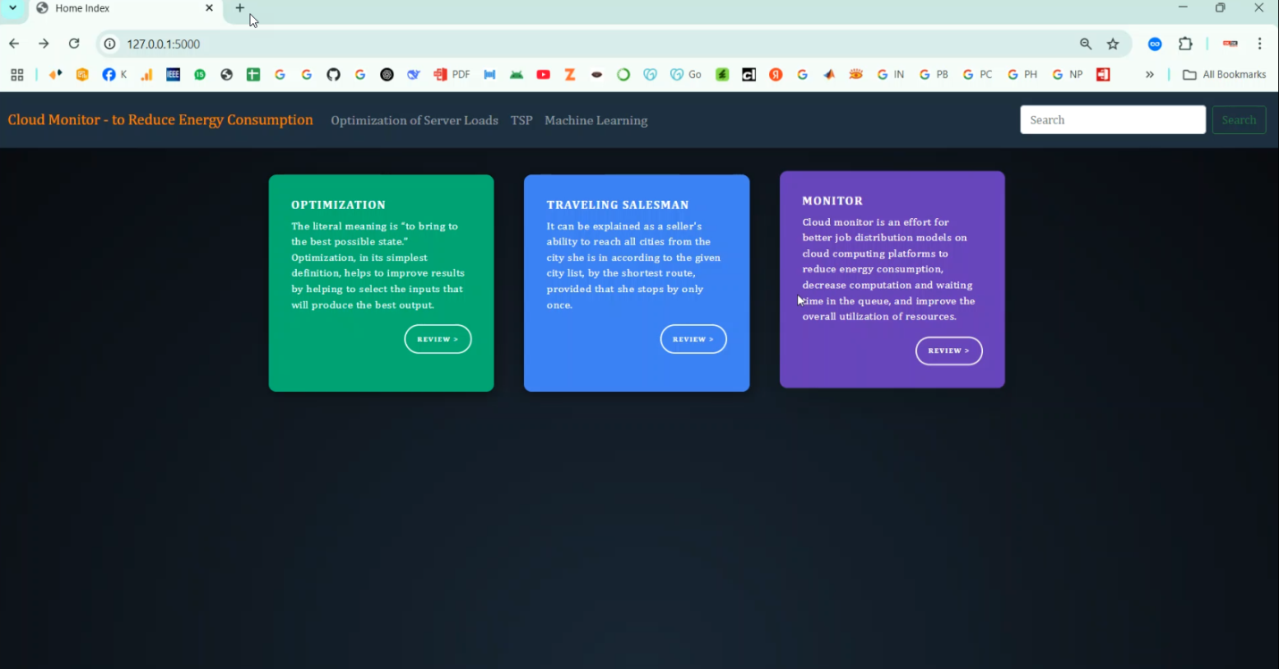

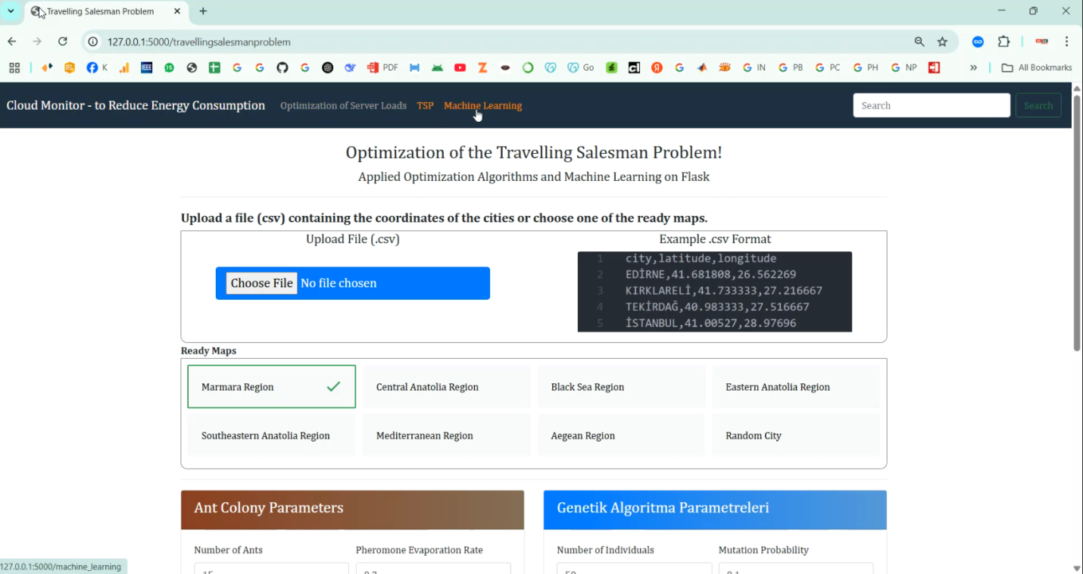

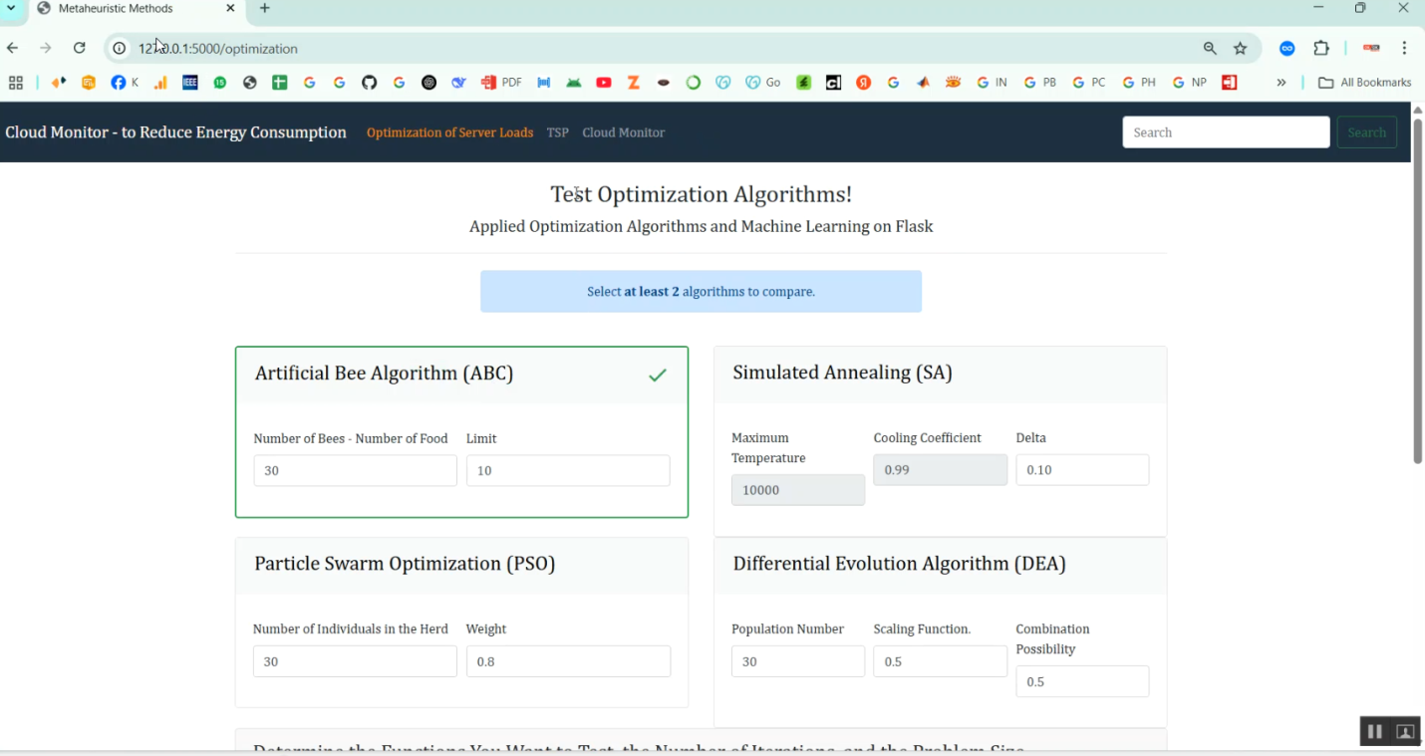

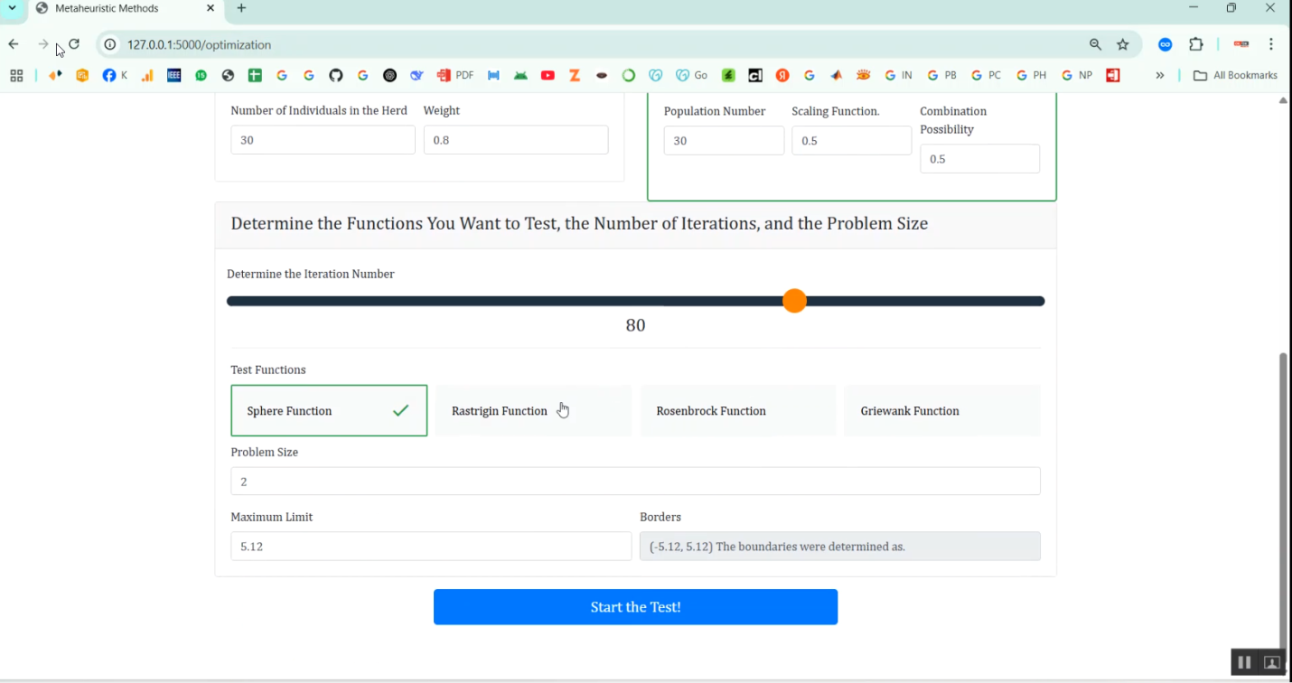

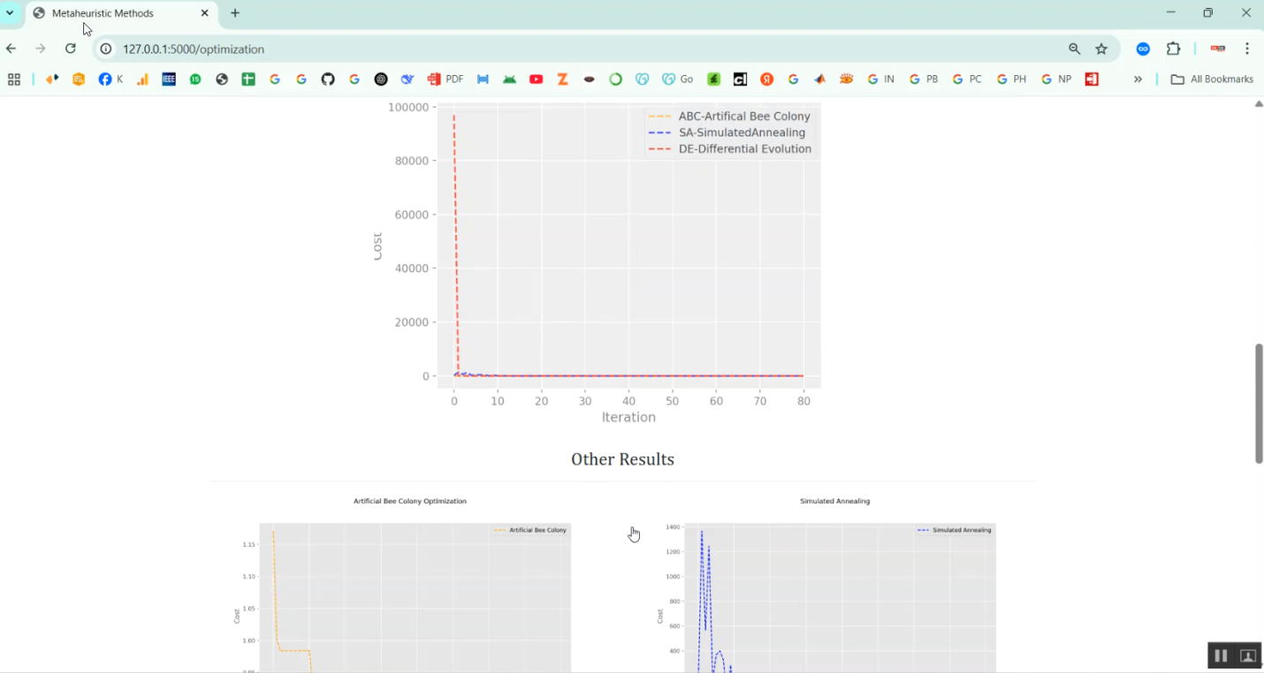

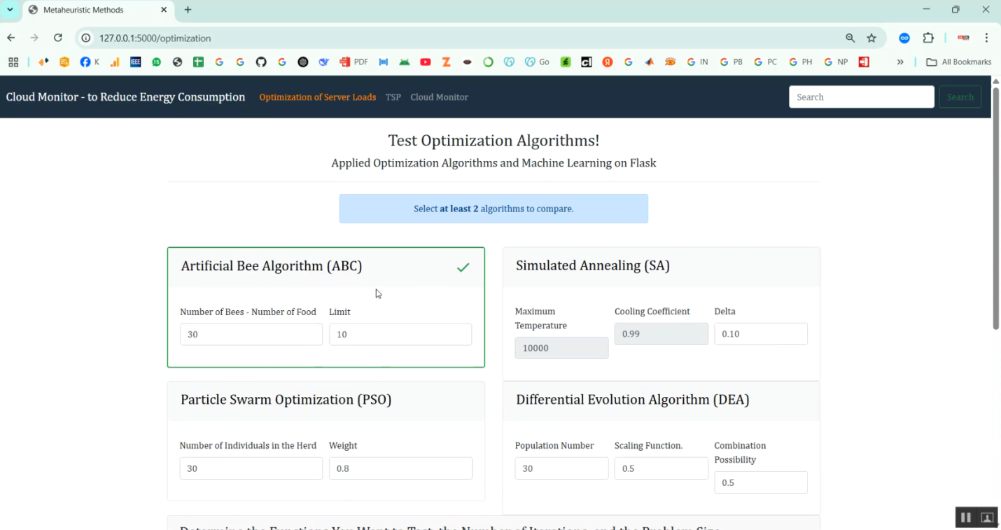

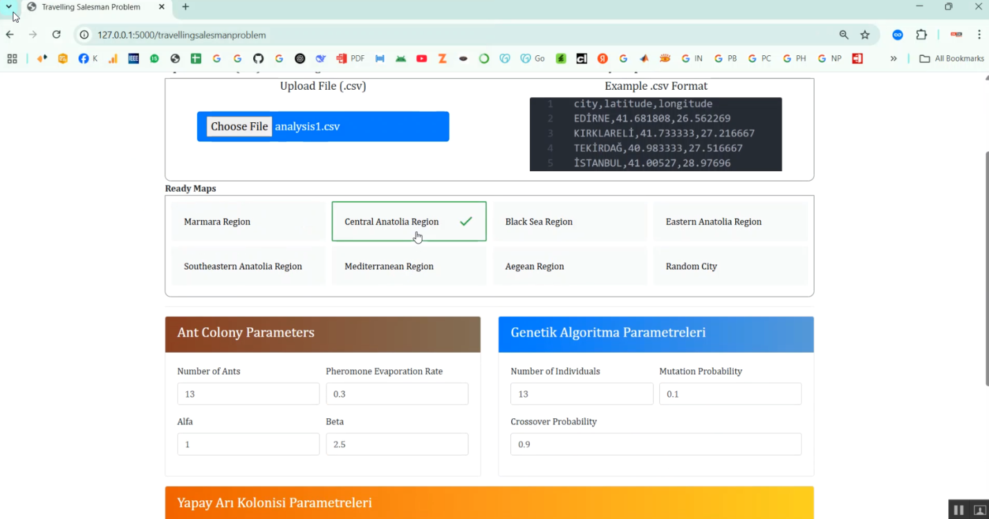

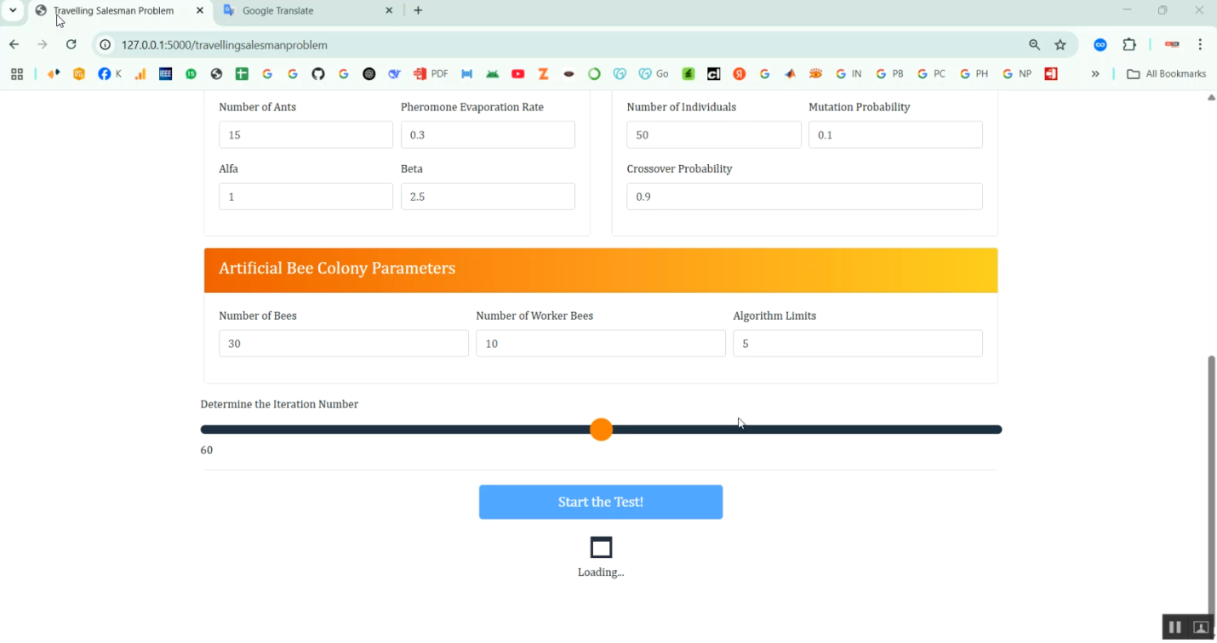

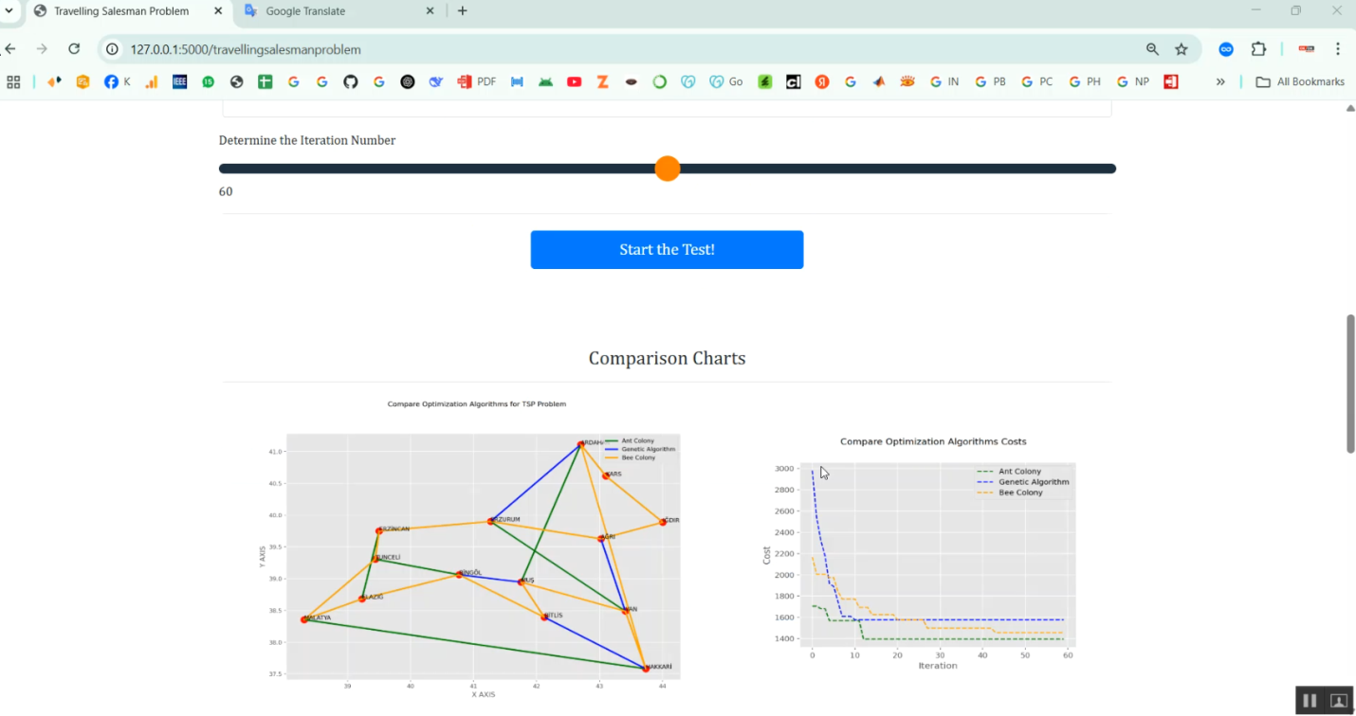

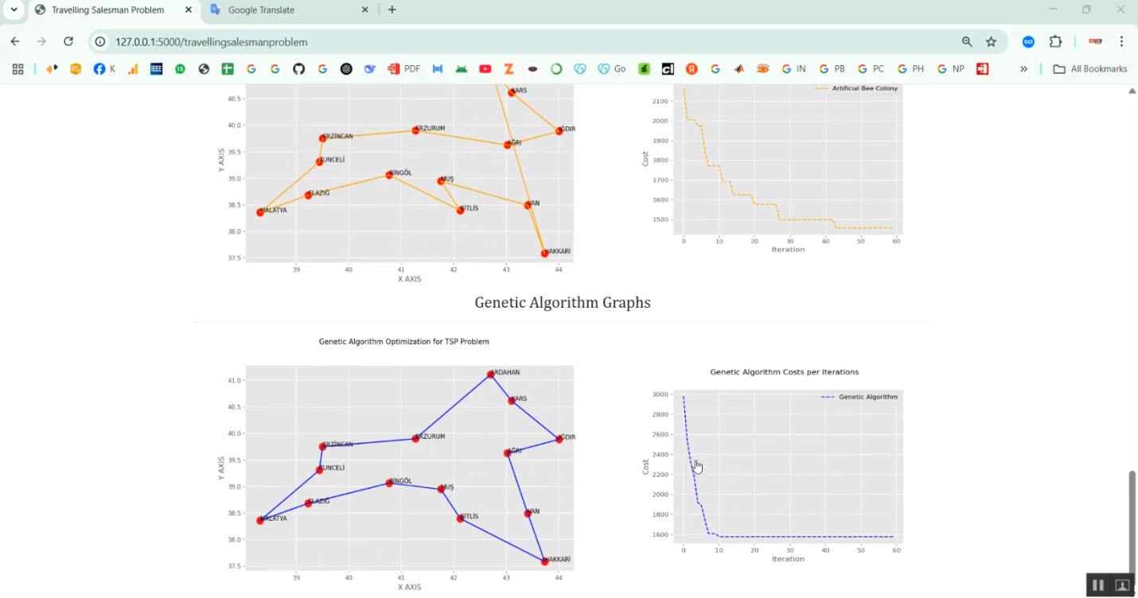

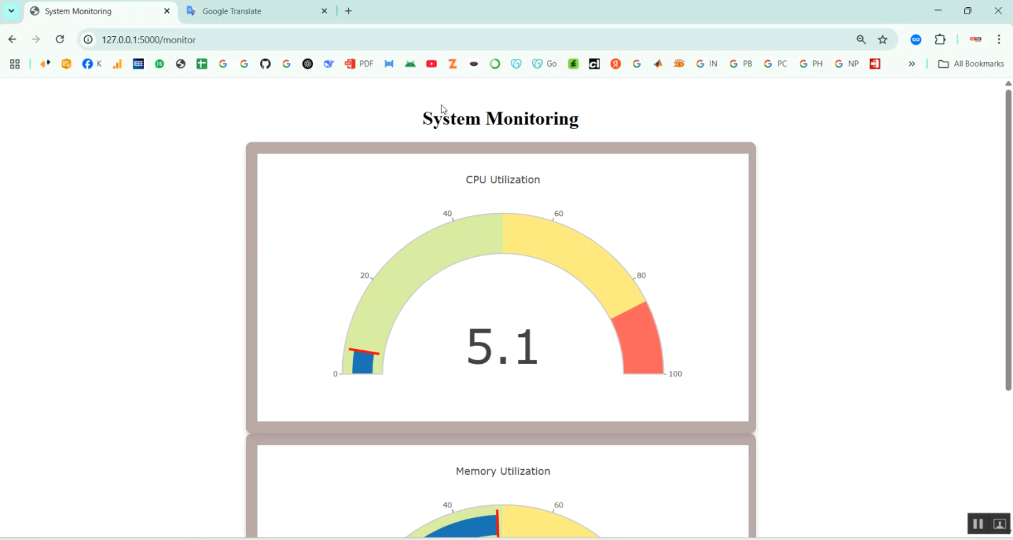

Future Work:
The future of cryptographic techniques in federated learning is expected to focus on the development of lightweight and adaptive security mechanisms that can operate efficiently in large-scale and resource-constrained environments. Emerging research is likely to emphasize hybrid cryptographic frameworks that intelligently combine secure aggregation, homomorphic encryption, and differential privacy to balance privacy guarantees with computational efficiency. In addition, advances in hardware acceleration, edge computing, and secure enclaves are anticipated to reduce the performance overhead associated with complex cryptographic operations. Standardized evaluation benchmarks and threat models will also play a crucial role in enabling fair comparison and real-world deployment of secure federated learning systems. Another important future direction lies in enhancing robustness, scalability, and trust in decentralized learning ecosystems. Integrating cryptographic techniques with blockchain, zero-knowledge proofs, and verifiable computation can improve transparency, auditability, and resistance to malicious participants. Furthermore, adaptive privacy mechanisms that dynamically adjust security levels based on data sensitivity and system context will gain prominence. As federated learning becomes more prevalent in domains such as healthcare, finance, and autonomous systems, future research must prioritize interoperable, regulation-compliant, and explainable cryptographic solutions that ensure secure and trustworthy collaborative intelligence.

Reference:
- Weizhao Jin, Yuhang Yao, Shanshan Han, Jiajun Gu, Carlee Joe-Wong, Srivatsan Ravi, Salman Avestimehr & Chaoyang He (2023) — FedML-HE: An Efficient Homomorphic-Encryption-Based Privacy-Preserving Federated Learning System — proposes selective encryption to balance HE privacy with performance in FL.
- Zizhen Liu, Si Chen, Jing Ye, Junfeng Fan, Huawei Li & Xiaowei Li (2022) — DHSA: Efficient Doubly Homomorphic Secure Aggregation for Cross-silo Federated Learning — introduces doubly homomorphic secure aggregation with multi-key HE for collusion-resistant FL.
- Xue Yang, Zifeng Liu, Xiaohu Tang, Rongxing Lu & Bo Liu (2023) — An Efficient and Multi-private Key Secure Aggregation for Federated Learning — presents an ElGamal-based secure aggregation that avoids trusted third parties.
- Jiaqi Xue, Mayank Kumar, Yuzhang Shang, Shangqian Gao, Rui Ning, Mengxin Zheng, Xiaoqian Jiang, Qian Lou (2025) — DictPFL: Efficient and Private Federated Learning on Encrypted Gradients — proposes a gradient encryption strategy reducing communication overhead in HE-based FL.
- Runhua Xu, Shiqi Gao, Chao Li, James Joshi & Jianxin Li (2025) — Dual Defense: Enhancing Privacy and Mitigating Poisoning Attacks in Federated Learning — integrates FHE with anomaly detection to defend against poisoning and privacy attacks.
- Runhua Xu, Bo Li, Chao Li, James B. D. Joshi, Shuai Ma & Jianxin Li (2025) — TAPFed: Threshold Secure Aggregation for Privacy-Preserving Federated Learning — introduces threshold functional encryption to protect against inference attacks.
- Oana Stan, Vincent Thouvenot, Aymen Boudguiga, Katarzyna Kapusta, Martin Zuber & Renaud Sirdey (2022) — A Secure Federated Learning: Analysis of Different Cryptographic Tools — analyzes DP, HE and MPC for secure FL.
- Lakshmi S.V.S.S. (2026) — Privacy-Preserving Federated Machine Learning on Blockchain: A Comprehensive Review of Homomorphic Encryption Techniques — reviews HE integration with blockchain for FL.
- Shashi Raj K, M. Manicka Raja, Ch G V N Prasad, Mallareddy Adudhodla, Shashank Shekhar Tiwari & Gaganjot Kaur (2025) — Federated Learning and Cryptography: A Secure Framework for IoT Data Privacy — applies AHE and SMPC for federated IoT systems.
- MDPI authors (2025) — A Review of Research on Secure Aggregation for Federated Learning — overviews HE, SMPC, DP and related aggregation techniques.
- M Moshawrab, M Adda, A Bouzouane, H Ibrahim & A Raad (2025) — HP_FLAP: Homomorphic and Polymorphic Federated Learning Aggregation of Parameters Framework — integrates HE and polymorphic encryption for inference-resistant FL.
- B. Zhu et al. (2025) — A Privacy-Preserving Federated Learning Scheme with Homomorphic Encryption — describes HE-based modules for secure learning and aggregation in distributed environments.
- X authors (2024) — Secure and Flexible Privacy-Preserving Federated Learning with Multi-Key FHE — proposes an mMFHE scheme for secure multi-party FL.
- Survey: Security Strategies in Federated Learning (2024) — A Survey of Security Strategies in Federated Learning: Defending Models, Data, and Privacy — covers cryptographic defenses, blockchain, DP, and attack mitigation.
- Federated Learning for 6G-Enabled Secure Communication Systems (2023) — includes discussion on secure aggregation and HE/MPC techniques used for privacy and communication efficiency in FL.

Conclusion:
A comprehensive review of cryptographic techniques applied in federated learning to ensure secure and privacy-preserving data collaboration. By systematically analyzing methods such as secure aggregation, homomorphic encryption, secure multiparty computation, differential privacy, and hybrid cryptographic frameworks, the review highlighted how these techniques address key security challenges including data leakage, inference attacks, and malicious model manipulation. The comparative analysis demonstrated that while cryptographic mechanisms significantly enhance confidentiality, integrity, and trust in federated learning systems, they also introduce trade-offs related to computational complexity, communication overhead, and scalability. The review emphasizes that no single cryptographic technique can fully satisfy all security and performance requirements of federated learning. Effective secure federated learning systems require carefully designed hybrid approaches that balance privacy guarantees with efficiency and practicality. By identifying existing limitations, research gaps, and emerging trends, this work provides valuable insights for researchers and practitioners aiming to develop robust, scalable, and regulation-compliant federated learning solutions. The findings of this review serve as a foundation for future advancements in secure distributed machine learning and trustworthy collaborative intelligence.

Bibliography:

Good Teachers are worth more than thousand books, we have them in Our Department
References Made From:
- User Interfaces in C#: Windows Forms and Custom Controls by Matthew MacDonald.

- Applied Microsoft® .NET Framework Programming (Pro-Developer) by Jeffrey Richter.

- Practical .Net2 and C#2: Harness the Platform, the Language, and the Framework by Patrick Smacchia.

- Data Communications and Networking, by Behrouz A Forouzan.

- Computer Networking: A Top-Down Approach, by James F. Kurose.

- Operating System Concepts, by Abraham Silberschatz.

- M. Armbrust, A. Fox, R. Griffith, A. D. Joseph, R. H. Katz, A. Konwinski, G. Lee, D. A. Patterson, A. Rabkin, I. Stoica, and M. Zaharia, “Above the clouds: A berkeley view of cloud computing,” University of California, Berkeley, Tech. Rep. USB-EECS-2009-28, Feb 2009.

- “The apache cassandra project,” http://cassandra.apache.org/.

- L. Lamport, “The part-time parliament,” ACM Transactions
on Computer Systems, vol. 16, pp. 133–169, 1998.

- N. Bonvin, T. G. Papaioannou, and K. Aberer, “Cost-efficient
and differentiated data availability guarantees in data clouds,”
in Proc. of the ICDE, Long Beach, CA, USA, 2010.

- O. Regev and N. Nisan, “The popcorn market. online markets
for computational resources,” Decision Support Systems,
vol. 28, no. 1-2, pp. 177 – 189, 2000.

- A. Helsinger and T. Wright, “Cougaar: A robust configurable
multi agent platform,” in Proc. of the IEEE Aerospace Conference,
2005.

- J. Brunelle, P. Hurst, J. Huth, L. Kang, C. Ng, D. C. Parkes,
M. Seltzer, J. Shank, and S. Youssef, “Egg: an extensible and
economics-inspired open grid computing platform,” in Proc.
of the GECON, Singapore, May 2006.

- J. Norris, K. Coleman, A. Fox, and G. Candea, “Oncall: Defeating
spikes with a free-market application cluster,” in Proc.
of the International Conference on Autonomic Computing,
New York, NY, USA, May 2004.

- C. Pautasso, T. Heinis, and G. Alonso, “Autonomic resource
provisioning for software business processes,” Information
and Software Technology, vol. 49, pp. 65–80, 2007.

- A. Dan, D. Davis, R. Kearney, A. Keller, R. King, D. Kuebler,
H. Ludwig, M. Polan, M. Spreitzer, and A. Youssef, “Web
services on demand: Wsla-driven automated management,”
IBM Syst. J., vol. 43, no. 1, pp. 136–158, 2004.

- M. Wang and T. Suda, “The bio-networking architecture: a
biologically inspired approach to the design of scalable, adaptive,
and survivable/available network applications,” in Proc.
of the IEEE Symposium on Applications and the Internet,
2001.

- N. Laranjeiro and M. Vieira, “Towards fault tolerance in
web services compositions,” in Proc. of the workshop on
engineering fault tolerant systems, New York, NY, USA,
2007.

- C. Engelmann, S. L. Scott, C. Leangsuksun, and X. He,
“Transparent symmetric active/active replication for servicelevel
high availability,” in Proc. of the CCGrid, 2007.

- J. Salas, F. Perez-Sorrosal, n.-M. M. Pati and R. Jim´enez-
Peris, “Ws-replication: a framework for highly available web
services,” in Proc. of the WWW, New York, NY, USA, 2006,

Sites Referred:
http://www.sourcefordgde.com
http://www.networkcomputing.com/
http://www.ieee.org
http://www.emule-project.net/

